MACHINE LEARNING CHECKPOINT 2
Group 4:
Mannava Priyanka Chowdary (11818052)
Jhansi Balla (11801681)
Likhitha Chandanati (11629832)
Sowmya Shetti (11722518)
soniya Tirumalasetty (11702585)
Problem Setting:
The proposed research builds a machine learning model to forecast airline journey rates from different flight criterion inputs. Various factors including airline business methods and weather patterns and departure timing and customer route preferences cause prices to change during flight ticket purchases. A prognostic model created for this purpose enables both travellers to improve booking selection decisions and ensures effective airline price planning. The problem belongs to predictive modelling because it requires simultaneous enforcement of regression and prediction of pricing dynamics along with non-linear ticket price trends. Through the agent a model applies Linear regression with Random Forest as well as XGBoost and Neural Networks to process input features to generate flight pricing predictions.
Methodology:
Framework Overview:
Our flight price prediction project framework starts from data loading and proceeds further through dimensions of feature engineering, data exploration, cleaning, visualization, and model training. This series of stages then leads to the final prediction and the analysis of models. Each step builds on findings from the previous one, ensuring a systematic approach to machine learning.
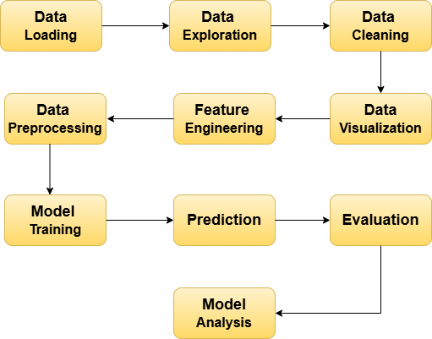
Components of the Framework:
Data Loading - First operations focus on acquiring and loading data from the flight ticket price dataset.
Data Exploration - Data Exploration starts immediately after data loading through structural analysis to detect patterns before conducting procedural statistical analysis.
Data Cleaning - Data cleaning functions as a sequence following the exploratory phase for handling missing values as well as eliminating duplicates and inconsistencies.
Data Visualization - The visual representation phase emerges after cleaning to show the variable relationships and price trends in flights.
Feature Engineering - During the phase of feature engineering new meaningful components are created directly from available data sources.
Data Preprocessing - The feature engineering process leads to data preprocessing which includes two steps: categorical data gets encoded while numerical values receive normalization or standardizing operations.
Model Training - During Model Training phase different machine learning algorithms receive application to the pre processed dataset for training the model.
Prediction - When training completes the model proceeds to predict flight data points that have never been used in training.
Evaluation - Model performance evaluation involves standardized assessment of metrics that includes the Root Mean Squared Error (RMSE) calculation method and Mean Absolute Error (MAE) algorithm together with R² (Coefficient of Determination).
Model Analysis - Model Analysis completes the process by interpreting results then examines model errors while applying improvements for enhanced accuracy.
States: They are learned through training. Has learned trend patterns of flight prices from the input and becomes increasingly adept at making accurate predictions. Increased usage of the model results in enhancing pattern detection abilities including change of season and change of route and time-based change of price.
Environment: A Python environment having as its major installations Pandas, NumPy and Scikit-learn, TensorFlow, and XGBoost forms the core of the system for flight price forecasting and supports handling the data. Jupyter Notebooks and remote environments are where the system is created and programmed. Matplotlib and Seaborn are the part of the visualization task. In-time predictions from Flask APIs and from the cloud are made exposed to the users when the system is live.
Model Description:
The flight price prediction system relies on machine learning regression models which include linear regression, random forest, XGBoost, and neural network models, whereby historical flight data is analyzed to predict future prices. Here, Random forest or XGBoost are considered the main models because they handle non-linear relationships well and they are robust to overfitting whereas Linear Regression and Neural Network are considered as alternative models. Linear Regression works as the baseline model assuming a linear relationship between features and prices. Neural Networks capture complex patterns through multiple layers. Random forests helps to construct multiple decision trees and gives us the average prediction of all the trees. XGBoost improves the random forest using a boosting technique where trees are constructed sequentially and each tree corrects the error from the previous one. These models are capable of capturing various patterns of pricing influenced by the date, time, and route. The optimization of model accuracy through hyperparameter tuning during the training process will take place. Performance and reliability in making predictions are measured using evaluation metrics such as R² Score, root mean square error (RMSE), and mean absolute error (MAE).
Implementation Details:
It implements the project in Python by using libraries for data handling, analytical purposes, and machine learning applications. Manipulation and numerical computation of data are handled using Pandas and NumPy while Matplotlib and Seaborn are responsible for data visualization. Machine learning algorithms, such as Linear Regression, Random Forest, and XGBoost, are supported by Scikit-learn besides building neural networks using TensorFlow (Keras). It starts from downloading and processing the data based on the flight price dataset along with its pre-processing of missing values and date/time related features into numerical representation of day, month, and hour. Categorical variables are one-hot encoded, whereas numerical features are standardized with StandardScaler. An 80:20 split gives training and testing data, respectively. Models are trained and tested with RMSE, R², and MAPE metrics. Tree-based methods of Random Forest and XGBoost rely on 100 trees (n_estimators=100). A Neural Network made up of two layers (64 and 32 neurons, respectively) is trained over 50 epochs using a batch size of 32 with Adam optimizer.
Evaluation Plan:
The performance of the models will be evaluated against certain parameters: RMSE (Root Mean Squared Error), R² Score, and MAPE (Mean Absolute Percentage Error). RMSE indicates the average magnitude of the errors in prediction, with larger errors being penalized more; thus, it relates directly to how well a model performs. R² Score indicates how well a model accounts for the variability in the flight prices, with values closer to one being a better fit. MAPE indicates the percentage error, thereby providing a means of evaluating prediction accuracy, along with providing a basis for comparison on varying models' performances.
Cross Validation:
This project will evaluate through train-test split, which is a robust technique for model evaluation. The dataset will be divided into training set and test set using the 80-20 ratio where training set forms 80% of the dataset while test set makes up 20%. This method guarantees a fair assessment of model performance on unknown data. K-fold cross-validation is also an alternative method that could be used for better generalization, but the choice here is on the train-test split since it is a simple and efficient method having regard to the size of the dataset and that the work focuses more on evaluating the model.
Challenges:
Overfitting: Various models are used (Random Forest, XGBoost, Neural Networks, Linear Regression), and the risk of overfitting is present, especially for complex models such as decision trees or neural networks. Overfitting occurs when a model learns the training data excessively well, picking up noise and irrelevant patterns in the process, which leads to poor generalization to unseen data.
Data Imbalance: Even though data sets about flight prices hardly project highly imbalanced traits, variations in certain categories like airlines or routes could set a target variable (price) astray. In cases where one category is more favoured than another, the model instead will develop a bias towards this frequent category.
Model Interpretability: Even advanced models like XGBoost and Neural Networks might provide high accuracy, they are less interpretable.
Limitations:
Time-Based Features: The influence of departure time and seasonal trends are not captured by the models. It may struggle to generalize the new trends like sudden market shifts, changes in the customer behaviour since it is considered as historical data.
Generalization: models would be trained on a given specific dataset, so that the generalizability to other datasets may be limited, for example, other airlines or regions. These models may also struggle with out-of-sample data differing from the training data.
Preliminary Results:
The machine learning approach for Flight Price Prediction is validated using initial experiments and results. Model Performance metrics and visualizations are the evidence that supports our method is effective.
Model Implementation:
Read the dataset into a variable called “df”.
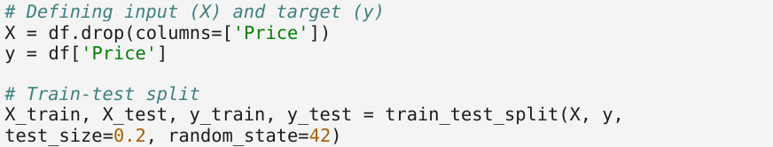
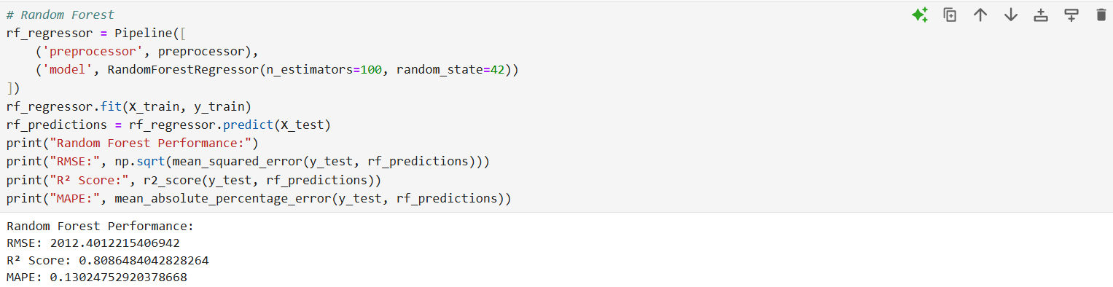
Random Forest Regressor got R² score of 0.8086, which means that it can explain almost 80.86% of the variance for the target variable. RMSE value was found to be 2012.40 and MAPE to the tune of 13.02%. The model shows good performance with expected improvement expected.
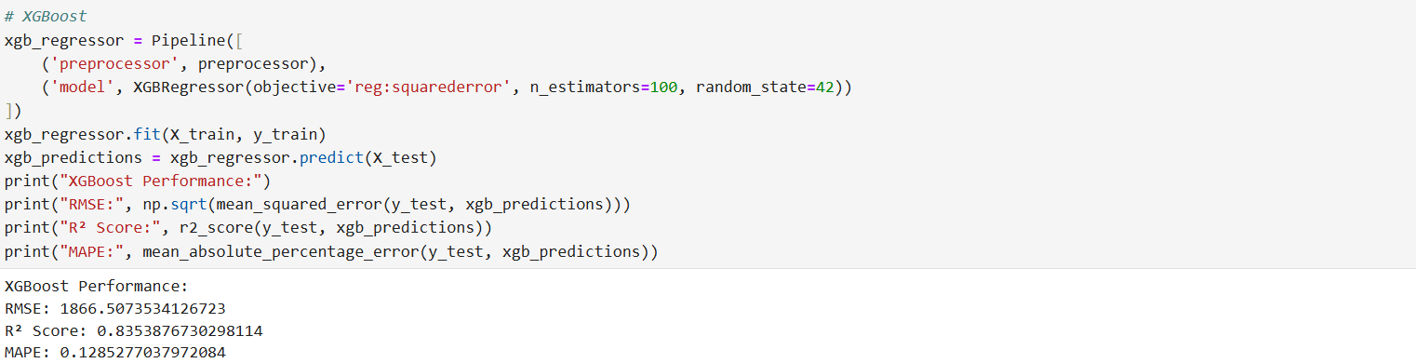
XGBoost Regressor gave an R² score of 0.8354, meaning it could explain 83.54% of the variance in the target variable. The predictive accuracy of this regressor is high when compared to Random Forest, revealing lower RMSE values (1866.51) and lower values of MAPE (12.85%).
Based on the above snapshot, XGBoost and Random Forest have yielded good results for predicting the flight prices compared with other models Linear Regression and Neural Networks.
Table of Metrics:
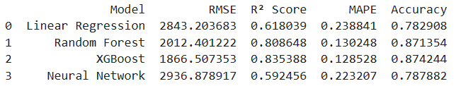
Visualizations:
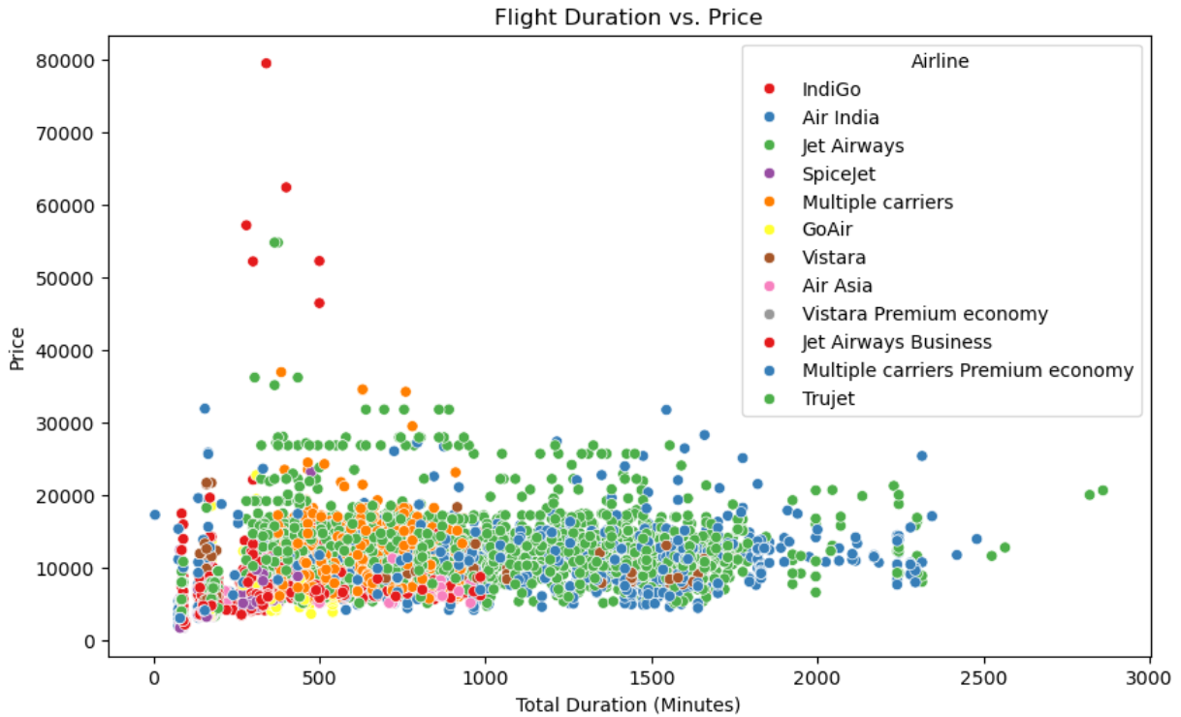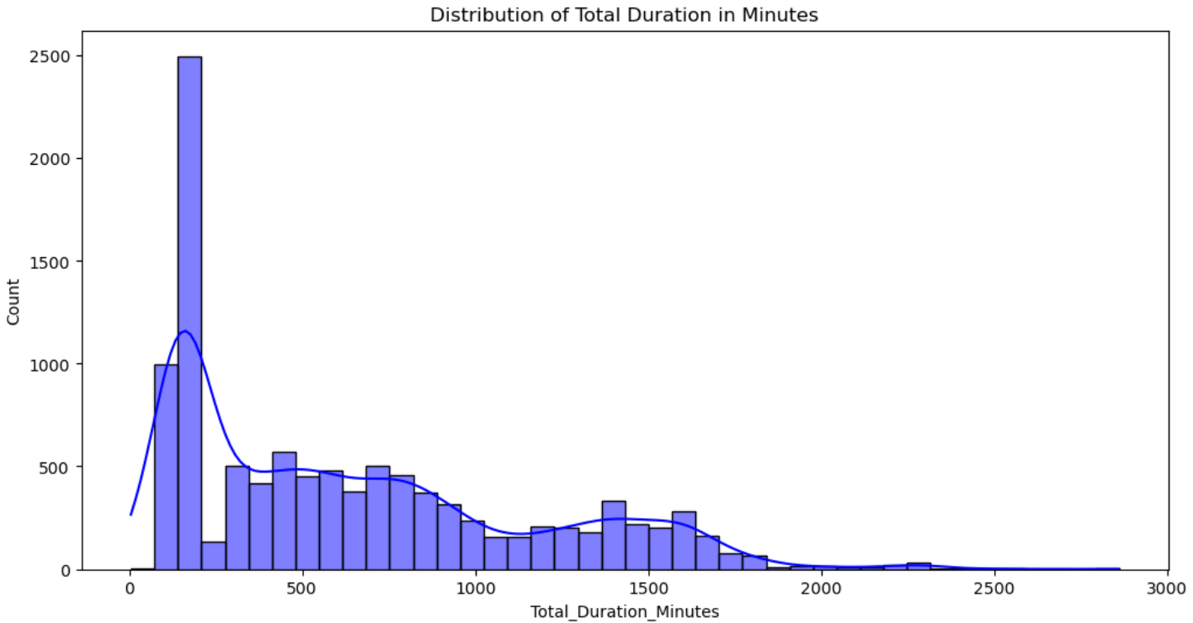
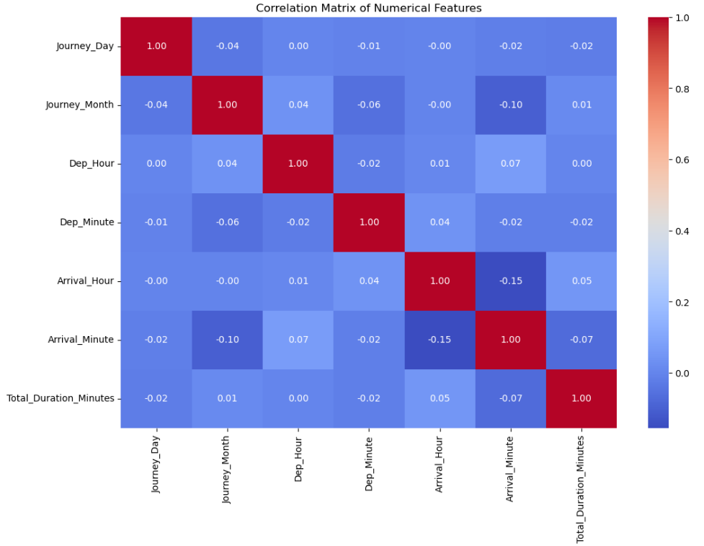
A scatter plot shows that quite short flights actually have a price variance between the minimum and maximum value: they sell below 3,000 and even above 30,000. Premium airlines like Jet Airways and Air India charge between 50,000 and even moderate travel times. Budget airlines, such as SpiceJet, GoAir and AirAsia, generally charge below 20,000 for flights about 1500 minutes long- still have erratic price fluctuations, as stops, demand, and service class, in this case, they are affecting the price.
The Histogram distribution of total flight durations does show a certain right skew, with most flights having short durations under 500 minutes, indicating that most of the routes are relatively short-distance. But, on the other hand, above 1500 minutes, some flights are classified as long-duration flights, indicating the presence of multisource or international routes with long traveling time.
The correlation between Journey Day and Journey Month -0.04 is very weak which indicates they have no connection. The independence between Departure Hour and Departure Minute becomes evident because their correlation stands at 0.01. Later arrival times create a slight decrease in the arrival minutes measure at a rate of -0.15 according to the correlation data.

Key observations:
In terms of RMSE and R² scores, Random Forest and XGBoost have consistently outperformed any other model. With lower RMSE values and higher R² values, these models are better suited for capturing complex relationships between flight features and prices. According to feature importance graphs, important attributes in the prediction of ticket prices include the airline, journey time, and the number of stops. This proves that Random Forest and XGBoost are effective models for airline prices, with both outperforming the Neural network and Linear regression, which underperformed with higher RMSE and lower R² values. This further strengthens the basis for the selection of these two models as principal ones and the argument for their suitability for further refinement.
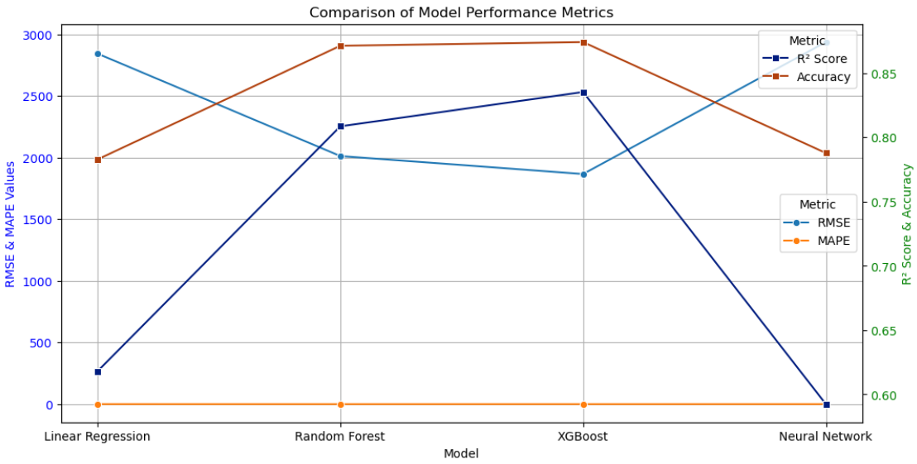
Issues and Findings:
- Influence of time on price dynamics: An unpredicted result was the high significance of the departure timing on ticket prices, surprisingly higher compared to how much they had estimated earlier. This suggests that dynamic pricing plays a significant role in determining flight costs; thus, models would have to treat time-based features differently.
- Data issues: Outliers and missing values were very significant through all stages of preprocessing for model stability. The models were shown to perform better after successful attempts to solve the issues, hence highlighting the importance of effective data cleaning.
Performance Improvement:
We will take multiple strategies to optimize model performance. In Hyperparameter tuning, Random Forest and XGBoost parameters will be tuned by either Grid Search or Random Search, aims to reduce the overfitting of the model. Feature Engineering would include new additional features, such as day of the week or holiday season, while even as we select the most significant for model performance enhancement. Here, to extract features we will use SHAP and LIME. Cross-Validation and Ensemble techniques such as k-fold cross-validation and the combination of multiple models will be used to improve generalization and accuracy. Lastly, it deals with data quality by handling missing values, outliers, and inconsistencies for clean data in training. These changes will be measured by RMSE, R² Score, and MAPE, as the improvements will be compared with baseline models.

